RESEARCH DOCUMENT

**Group:** Nameless Inc.

**Client:** Bas World

**Project:** Keywatcher dashboard

**Index**

1. Summary Section 3
2. Data to Display on the Dashboard 3
   1. User Interaction Overview 3
   2. Traffic Source Analysis 4
   3. Device and Browser Usage 5
   4. Geographic Distribution 6
   5. User and Company Insights 6
3. Dashboard analysis 10
4. AWS Database Options and Final Decision 16
5. Decision and Dockerized Setup 16
6. Conclusion dashboard analysis 18

**Data to Display on the Dashboard:**

1. **Summary Section**:
   * **Total User Events.**
2. "Total User Events Recorded: 10.000."

This figure represents all user events tracked by the system, including page views, interactions, and item selections.

* **Single Number/Metric Widget:** A prominent, standalone number shows the overall activity.
  + **New User Events.**

1. "New User Events: 1.200."

These are events where “eventMainType” is CREATE and “eventSubType” is “newUserEvent”, indicating new users interacting with the platform for the first time.

* **Single Number/Metric Widget:** Clearly shows the number of new user events in a simple format.
  + **Total Page Views.**
    1. "Total Page Views: 7.500."

Number of “PageVisitEvent” occurrences, representing how often users viewed various pages on the site or app.

* **Single Number/Metric Widget with Trend Line:** A number widget with a small trend line or percentage change shows overall activity and whether it's increasing or decreasing.
* **Average amount of events per user**

1. "Average Number of Events Per User: 12.5"

Will be calculated based on “eventTimestamp”

* **Just a number**
* **Average amount of events per company**

1. "Average Number of Events Per Company: 14.7"

Will be calculated based on “eventTimestamp”

* **Just a number**

1. **User Interaction Overview:**
   * Most interacted elements and their counts.
2. "Add to Cart Button": 500 interactions.
3. "Search Bar": 1,200 interactions.
4. "Sign-Up Form": 300 interactions.

These counts show how often users interacted with specific elements, indicating which parts of the site or app are most engaging.

* **Bar Chart:** A bar chart allows for easy comparison of interaction counts across multiple elements.
  + Most/Least viewed and selected items.

**Most Viewed Items**:

1. "Product A": Viewed 700 times.
2. "Product B": Viewed 500 times.
3. "Product C": Viewed 450 times.

**Most Selected Items**:

1. "Product A": Selected 300 times.
2. "Product B": Selected 250 times.

**Least Viewed Items**:

1. "Product A": Viewed 700 times.
2. "Product B": Viewed 500 times.
3. "Product C": Viewed 450 times.

**Least Selected Items**:

1. "Product A": Selected 300 times.
2. "Product B": Selected 250 times.

**Division of events among the time**

1. 00.00-01.00: 345 events
2. 01.00 - 02.00: 167 events

This helps identify popular products or content.

* **Horizontal Bar Chart or Table:** For a few items, a horizontal bar chart is ideal for comparison. For many items, a table with ranks and counts is more readable.

1. **Traffic Source Analysis:**
   * Breakdown of sessions by “utmParameters” (e.g., source, medium, campaign).

**Source Breakdown**:

1. Google: 600 sessions (40%).
2. Facebook: 300 sessions (20%).
3. LinkedIn: 200 sessions (13.3%).
4. Direct: 200 sessions (13.3%).
5. Bing: 100 sessions (6.7%).

**Medium Breakdown**:

1. Organic Search: 700 sessions (46.7%).
2. Paid Search: 400 sessions (26.7%).
3. Social Media: 400 sessions (26.7%).

**Campaign Breakdown**:

1. Campaign A: 150 sessions (10%).
2. Campaign B: 120 sessions (8%).
3. Campaign C: 100 sessions (6.7%).

This breakdown helps understand which channels and campaigns are most effective in driving traffic.

* **Pie Chart or Stacked Bar Chart:** Pie charts are effective for showing proportions of traffic sources. Stacked bar charts are useful for comparing traffic mediums or campaigns over time.

1. **Device and Browser Usage:**
   * Pie charts or bar graphs showing device types, operating systems, and browser usage.

**Device Types**:

1. Desktop: 50%.
2. Mobile: 40%.
3. Tablet: 10%.

**Operating Systems**:

1. Windows: 45%.
2. macOS: 30%.
3. iOS: 15%.
4. Android: 10%.

**Browsers**:

1. Chrome: 60%.
2. Safari: 25%.
3. Firefox: 10%.
4. Edge: 5%.

This information shows the distribution of users' devices, operating systems, and browsers, useful for optimizing content and functionality.

* **Pie Charts and Vertical Bar Charts:** Pie charts work well for categorical data like device types, and bar charts are effective for comparing multiple categories like OS and browser usage.

1. **Geographic Distribution:**
   * Map visualization showing user distribution by country, region, and city.

**Top 5 Countries**:

1. USA: 3,000 users.
2. UK: 1,500 users.
3. India: 1,200 users.
4. Canada: 800 users.
5. Germany: 600 users.

**Top 5 Cities**:

1. New York: 1,200 users.
2. London: 900 users.
3. Mumbai: 500 users.
4. Toronto: 400 users.
5. Berlin: 300 users.

A map visualization would highlight the geographical hotspots of user activity, aiding in regional marketing and service decisions.

* **Geographical Heat Map:** A heat map visualizes user density by geographic location, making it easy to identify high-activity regions and cities.

1. **User and Company Insights:**
   * List of top users and companies interacting with the system.

**Top 5 Users**:

1. User 1: 150 interactions.
2. User 2: 120 interactions.
3. User 3: 110 interactions.
4. User 4: 100 interactions.
5. User 5: 95 interactions.

**Top 5 Companies**:

1. Company A: 300 interactions.
2. Company B: 250 interactions.
3. Company C: 200 interactions.
4. Company D: 150 interactions.
5. Company E: 100 interactions.

This insight shows which users and companies are most engaged, which can be crucial for customer relationship management and targeting specific audiences.

* **Table with Sorting and Filtering Capabilities:** Tables are best for listing detailed information such as user interactions and company engagement. Sorting and filtering help in focusing on specific users or companies of interest.
* Metrics of new users and companies

**New users for some period of time:**

1. “New users today: 125”

This metrics will show, how much new users visited website today

* **Just a number**

1. “New users this month: 967”

This metrics will show, how much new users visited website this month

* **Just a number**

1. “New users this year: 4947”

This metrics will show, how much new users visited website this year

* **Just a number**

**New companies for some period of time:**

1. “New companies today: 125”

This metrics will show, how much new companies visited website today

* **Just a number**

1. “New companies this month: 967”

This metrics will show, how much new companies visited website this month

* **Just a number**

1. “New companies this year: 4947”

This metrics will show, how much new companies visited website this year

* **Just a number**

**PROTOTYPES**

### **Summary section page**

**Top Row: Three large metric widgets:**

* **Widget 1: Total User Events (single number with a small trend arrow).**
* **Widget 2: New User Events (number with a percentage change).**
* **Widget 3: Total Page Views (number with a line graph showing recent changes).**

**Middle Section:**

* **Line Chart: User events over time to show trends.**
* **Bottom Section:**
* **Bar Chart: Distribution of different event types over time.**

### **2. User Interaction Overview Page**

**Top Section**:

* **Bar Chart**: Most interacted elements, showing elements on the X-axis and interaction counts on the Y-axis.
* **Bottom Section**:
* **Horizontal Bar Chart or Table**: For most viewed and selected items. Each row or bar represents an item with corresponding view and selection counts.

### **3. Traffic Source Analysis Page**

**Left Section**:

* **Pie Chart: Breakdown of sessions by source (e.g., Google, Facebook).**

**Right Section**:

* **Stacked Bar Chart: Sessions by medium (organic, paid, social media) over time.**
* **Bottom Section:**
* **Table: Campaign performance showing sessions, clicks, and conversions per campaign.**

### **4. Device and Browser Usage Page**

**Top Section**:

* **Three Pie Charts:**
  + **Pie Chart 1: Device Types (e.g., desktop, mobile, tablet).**
  + **Pie Chart 2: Operating Systems (e.g., Windows, macOS, iOS).**
  + **Pie Chart 3: Browser Usage (e.g., Chrome, Safari, Firefox).**

**Bottom Section**:

* **Vertical Bar Chart**: Comparison of common devices and browsers by usage percentage.

### **5. Geographic Distribution Page**

**Center Section**:

* **Geographical Heat Map: Shows user density by country and city.**

**Bottom Section**:

* **Table: Detailed regional statistics (e.g., country, city, number of users, sessions).**

### **6. User and Company Insights Page**

**Top Section**:

* **Filters and Search: Dropdowns and search bar for filtering by user/company attributes (e.g., name, interaction count).**

**Bottom Section**:

* **Table: Lists top users and companies with columns for name, interactions, and sessions. The table should be sortable and filterable.**

**Dashboard analysis**

**Example 1**

Figure 1: (What Is Digital Dashboard? – View 5 Examples | Geckoboard, n.d.)

Sessions (a day, a week, yearly, all time, average etc.), Conversions (clicked ads), by medium (could be browser).

**Example 2**

Figure 2: (What Is Digital Dashboard? – View 5 Examples | Geckoboard, n.d.)

Revenue (daily, weekly, yearly, average etc.), orders, advertisements (amount of), order completions (based on ads), order cancellations.

**Example 3**

Figure 3: (What Is Digital Dashboard? – View 5 Examples | Geckoboard, n.d.)

Outreach (Made calls, email sent, social impressions), new customers, average calls duration.

**Example 4**

Figure 4: (What Is Digital Dashboard? – View 5 Examples | Geckoboard, n.d.)

Monthly revenue (this month, average), cost of ads a customer, revenue per customer account, customers and signups, the amount of months until no money is left.

**Example 5**

Figure 5: (What Is Digital Dashboard? – View 5 Examples | Geckoboard, n.d.)

Sales (Daily, weekly, monthly, yearly, yesterday, etc.), willingness of customers to recommend a product, biggest deal, Recent feedback, social followers, Twitter mentions, Website (Users, enquiries), Current visitors location

**Example 6**

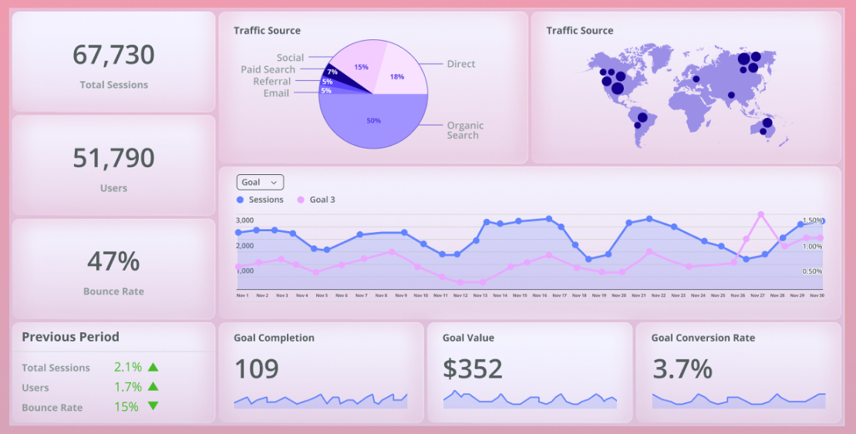

Figure 6: (How to Build a Web Analytics Dashboard & Which Metrics to Include, n.d.)

Total sessions, Users, Bounce rate (the number of users which leave without an action), comparison to previous months, traffic source (country or referral type), Goal (completion, Value, conversion rate).

**Example 7**

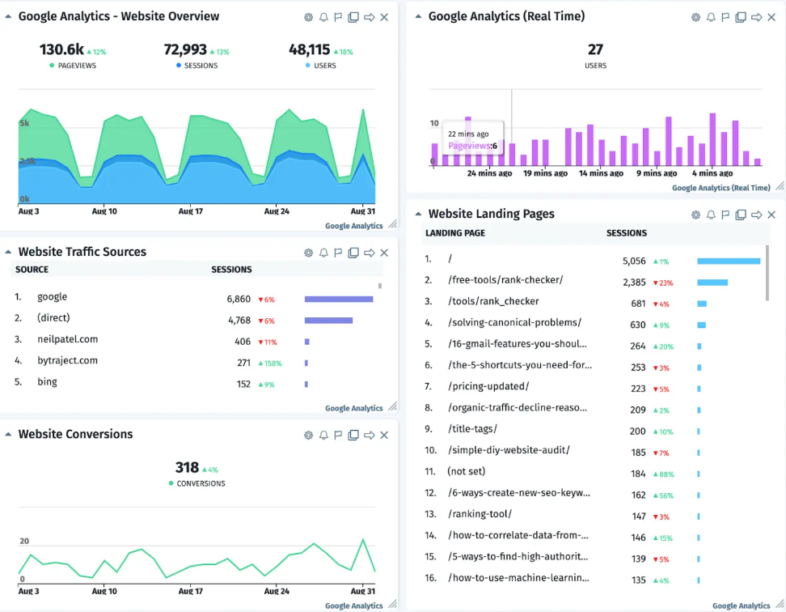

Figure 7: (Sussman, 2022)

Pageviews, Sessions, users, website traffic sources, Real time users, Landing page (which page the users landed on)

**Example 8**

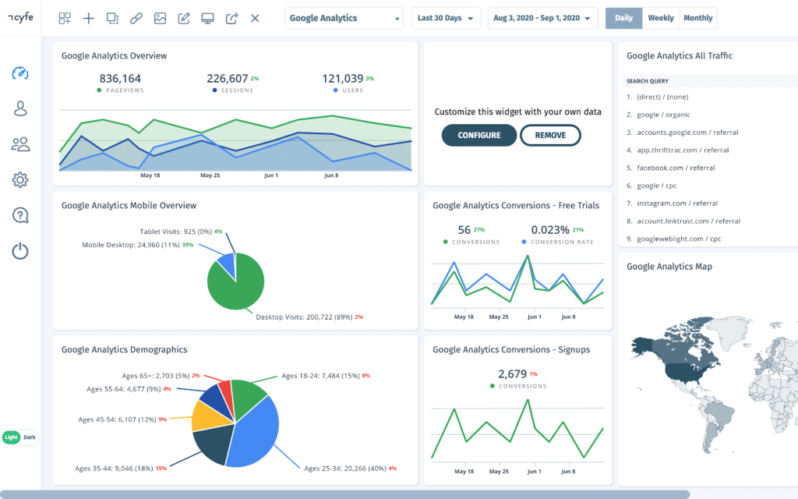

Figure 8: (Sussman, 2022)

Pageviews, sessions, users, Device overview (pie chart), Age pie chart, Free trial conversion, signup conversion, Search queries, analytics map.

**Decision and Dockerized Setup:**

**Why Docker?**

* **Consistency:** Ensures identical environments across development and production.
* **Ease of Deployment:** Simplifies the deployment of back-end, front-end, and databases such as MongoDB or MySQL.
* **Portability:** Applications can run on any platform with Docker installed.
* **Scalability:** Individual components can be scaled independently with minimal effort.

**AWS Database Options and Final Decision :**

**Amazon DocumentDB (Preferred Database)**

* A fully managed NoSQL document database service compatible with MongoDB.
* Features automatic scaling, high availability, and multi-AZ support.
* Ideal for semi-structured data and modern applications requiring high performance.

**Amazon RDS**

* A relational database service supporting MySQL, PostgreSQL, and more.
* Includes automatic backups, replication, and monitoring, making it suitable for structured data.

**Amazon DynamoDB**

* A serverless NoSQL database optimized for low-latency, high-performance key-value workloads.
* Automatically scales to meet demand, making it ideal for unpredictable traffic spikes.

**Why Docker for the Database?**

* **Flexibility:** Databases like MySQL or MongoDB can be containerized for local testing or deployed to AWS ECS/EKS.
* **Portability:** Containers can be moved between environments seamlessly.
* **Customization:** Docker allows fine-tuning of configurations for the application’s needs.

**Client Handover Plan**

1. **Docker Images or Repository URLs:** All components will be containerized, and the necessary images or links to GitHub repositories will be shared.
2. **Setup Documentation:** A comprehensive guide will be included to ensure a smooth transition for the client.

**Advantages of a Dockerized Setup**

* **Consistency:** Guarantees identical environments in development and production.
* **Flexibility:** Easy to migrate to other hosting providers or adapt to changing requirements.
* **Cost-Effective:** Avoids AWS-managed service costs by self-managing containers.
* **Scalability:** Individual components can scale based on demand.
* **Ease of Use:** Simplifies maintenance for the client post-handover.

**Conclusion dashboard analysis**

Based on the dashboards which were analyzed it can be concluded that the most important factor in creating a business is money, it either directly shows cash flow or shows data which is related to cash flow. An also common factor is the users (sessions/customers), this will give the user of the dashboard a sense of scale of the business. A business decision might need to be made based on the revenue and the number of users.

The source (both geolocation as traffic source) is also a common factor between the different dashboards. The source (or sometimes called by medium) might show the dashboard user more about where to invest in (advertising), or where to invest less in.

The location is also seen as valuable information because areas of high demand/usage can indicate that either a new branch of the company needs to be opened there, or any kind of distribution center needs to be opened.

Based on the research done on the dashboards it can be concluded that a few things are seen as valuable data on a dashboard:

* User statistics
  + Number of users.
  + Cost per user.
  + Source (or medium) of the user.
  + Location of user.
* Money statistics
  + Spent money.
  + Revenue.
  + Cost for a user to get to the site (e.g. Cost Per Click).
  + Etc.

This valuable data will give the user of the dashboard a better understanding of the business and could increase profit when dealt with correctly.